Ref No:
Sri Krishna Institute of Technology, Bengaluru-560090


COURSE PLAN
Academic Year - 2019-2020

Academic Evaluation and Monitoring Cell

Program: | BE- Electrical and Electronics Engineering
Semester: | 5
Course Code: | 17EEL58
Course Title: | Power Electronics
Credit/L-T-P: | 3/0-1-2
Total Contact Hours: | 36
Course Plan Author: | Chaitra A S

#29, Hesaragatta Main Road, Chimney Hills
Chikkabanavara Post Bengaluru – 560090, Karnataka, India
Phone / Fax :080-23721477/28392221/23721315
Web: www,skit.org, e-mail:

Table of Contents
A. LABORATORY INFORMATION 4
1. Laboratory Overview 4
2. Laboratory Content 4
3. Laboratory Material 5
4. Laboratory Prerequisites: 5
5. Content for Placement, Profession, HE and GATE 5
B. Laboratory Instructions 6
1. General Instructions 6
2. Laboratory Specific Instructions 6
C. OBE PARAMETERS 6
1. Laboratory Outcomes 6
2. Laboratory Applications 7
3. Mapping And Justification 8
4. Articulation Matrix 8
5. Curricular Gap and Experiments 9
6. Experiments Beyond Syllabus 9
D. COURSE ASSESSMENT 10
1. Laboratory Coverage 10
2. Continuous Internal Assessment (CIA) 10
E. EXPERIMENTS 11
Experiment 01 : Structure of C program 11
Experiment 02 : Keywords and identifiers 12
Experiment 03 : ……… 13
Experiment 04 : ……… 13
F. Content to Experiment Outcomes 14
1. TLPA Parameters 14
2. Concepts and Outcomes: 15

INSTRUCTIONS TO TEACHERS
- Classroom / Lab activity shall be started after taking attendance.
- Attendance shall only be signed in the classroom by students.
- Three hours attendance should be given to each Lab.
- Use only Blue or Black Pen to fill the attendance.
- Attendance shall be updated on-line & status discussed in DUGC.
- No attendance should be added to late comers.
- Modification of any attendance, over writings, etc is strictly prohibited.
- Updated register is to be brought to every academic review meeting as per the COE.

17EEL58 : POWER ELECTRONICS LAB

A. LABORATORY INFORMATION

1. Lab Overview
Degree: | B.E | Program: | EE
Year / Semester : | 3 / 5 | Academic Year: | 2019
Course Title: | Power Electronics Lab | Course Code: | 17EEL58
Credit / L-T-P: | 3 / 0-1-2 | SEE Duration: | 180 Minutes
Total Contact Hours: | 36 Hrs | SEE Marks: | 60 Marks
CIA Marks: | 40 | Assignment | 1 / Module
Course Plan Author: | Chaitra A S | Sign | Dt :
Checked By: |  | Sign | Dt :

2. Lab Content
Unit | Title of the Experiments | Lab Hours | Concept | Blooms Level
1 | Static Characteristics of SCR. | 3 | Performance of SCR | L3  Apply
2 | Static Characteristics of MOSFET and IGBT | 3 | Performance of MOSFET & IGBT | L3  Apply
3 | Characteristic of TRIAC | 3 | Performance of TRIAC | L3  Apply
4 | SCR turn on circuit using synchronized UJT relaxation oscillator | 3 | UJT Triggering method | L3  Apply
5 | SCR digital triggering circuit for a single phase-controlled rectifier and ac voltage regulator. | 3 | Digital Triggering Method | L4  Analyze
6 | Single phase controlled full wave rectifier with R and R –L loads. | 3 | Rectification | L4  Analyze
7 | AC voltage controller using TRIAC and DIAC combination connected to R and RL loads. | 3 | Voltage Control | L4  Analyze
8 | Speed control of dc motor using single semi converter. | 3 | Speed Control | L4  Analyze
9 | Speed control of stepper motor. | 3 | Speed Control | L5  Evaluate
10 | Speed control of universal motor using ac voltage regulator | 3 | Speed Control | L4  Analyze
11 | Speed control of a separately excited D.C. Motor using an IGBT or MOSFET chopper. | 3 | Speed Control | L4  Analyze
12 | Design of Snubber circuit. | 3 | Snubber Protection | L5  Evaluate3

3. Lab Material
Unit | Details | Available
1 | Text books
 | Power Electronics: Circuits Devices and Applications BY Mohammad H Rashid, Pearson 4th Edition, 2014. | In Lib
2 | Reference books
1. | Power Electronics: Converters, Applications and Design Ned Mohan et al Wiley 3rd Edition, 2014 | In dept
2. | Power Electronics BY Daniel W Hart, McGraw Hill, 1 st Edition, 2011
3 | Elements of Power Electronics, Philip T Krein, Oxford, Indian Edition, 2008
3 | Others (Web, Video, Simulation, Notes etc.) | Not Available

4. Lab Prerequisites:
- | - | Base Course: |  | - | -
SNo | Course Code | Course Name | Topic / Description | Sem | Remarks
1 | 15ELN15 | Basic Electronics | 1. Knowledge on Basic working | 2 | -
2 | 15EE34 | Analog Electronic Circuits | FET, MOSFET Construction, working, Characteristics | 3 | -
Note: If prerequisites are not taught earlier, GAP in curriculum needs to be addressed. Include in Remarks and implement in B.5.

5. General Instructions
SNo | Instructions | Remarks
1 | Keep the lab neatly. Maintain silence.
2 | Maintain your lab observation and lab manual.
3 | Prepare your experiment in well advance.
4 | Check the power supply before use.
5 | Maintain discipline in the lab.
6 | After completion of your experiment switch off the power supply.
7 | Observation book and Lab record are compulsory.
8 | Students should report to the concerned lab as per the time table.
9 | After completion of the experiment, certification of the concerned staff in-charge in the observation book is necessary.
10 | Student should bring a notebook of 100 pages and should enter the readings /observations into the notebook while performing the experiment.

6. Lab Specific Instructions
SNo | Specific Instructions | Remarks
1 | Check for all the connections of the circuit and scope connections before powering the circuit, to avoid shorting or any ground looping, that may lead to electrical shocks or damage of equipment
2 | Check any connections for shorting two different voltage levels
3 | Check if you have connected load at the output
4 | Double check your wiring and circuit connections
5 | Apply low voltages or low power to check proper functionality of circuits while switching ON the circuit.
6 | Once functionality is proven, increase voltages or power, stopping at frequent levels to check for proper functioning of circuit or for any components is hot or for any electrical noise that can affect the circuit’s operation.
7 | Reduce the voltage or power slowly till it comes to zero.
8 | Switch of all the power supplies and remove the power supply connections.
9 | Avoid using long wires, that may get in your way while making adjustments or changing leads.
10 | Keep high voltage parts and connections out of the way from accidental touching and from any contacts to test equipment or any parts, connected to other voltage levels

B. OBE PARAMETERS

1. Lab / Course Outcomes
# | COs | Teach. Hours | Concept | Instr Method | Assessment Method | Blooms’ Level
1 | Obtain the static characteristic of SCR and their performance in terms of voltage & current. | 10 | Performance of SCR | Demonstrate | Unit Test,  Viva Voce | L3
2 | Compute static characteristics of MOSFET & IGBT and obtain their performance in terms of voltage & current. | 06 | Performance of MOSFET & IGBT | Demonstrate | Assignment | L3
3 | Compute static characteristics of TRIAC and obtain their performance in terms of voltage & current. | 07 | Performance of TRIAC | Demonstrate | Assignment and unit Test | L3
4 | To generate triggering pulses using UJT relaxation oscillator. | 03 | UJT Triggering method | Demonstrate | Assignment | L3
5 | Generator triggering pulses using SCR digital trigger circuit using single phase controlled rectifier. | 03 | Digital Triggering Method | Demonstrate | Unit test | L4
6 | Analyze the performance of a single phase full wave controlled rectified connected to R & RL load. | 03 | Rectification | Demonstrate | Assignment | L4
7 | Analyze the performance of AC voltage controller applied to R & RL load using TRIAC and DIAC. | 03 | Voltage Control | Demonstrate | Assignment and unit Test | L4
8 | Control the speed of DC motor using semi converter by varying firing angle. | 03 | Speed Control | Demonstrate | Assignment  Viva Voce | L4
9 | Control the speed of stepper motor. | 03 | Speed Control | Demonstrate | Assignment  Viva Voce | L5
10 | Control the speed of universal motor using controlled rectifier. | 03 | Speed Control | Demonstrate | Assignment  Viva Voce | L4
11 | Control the speed of a separately exited DC motor using MOSFET chopper by varying duty cycle of the thyristor. | 03 | Speed Control | Demonstrate | Assignment | L4
12 | Design the snubber circuit for the protection of power circuit from faults. | 03 | Snubber Protection | Demonstrate | Assignment  Unit Test | L5
- | Total | 36 | - | - | - | -
Note: Identify a max of 2 Concepts per unit. Write 1 CO per concept.

2. Lab Applications
SNo | Application Area | CO | Level
1 | SCR are used in Industrial application such as induction heating, dielectric heating and lamp dimming. | CO1 | L3
2 | SCR are used in static AC /DC circuit breakers, control rectifiers, tap changers | CO1 | L3
3 | Transistors are used in low power logic gates, DC motor drives, AC motor drives | CO2 | L3
4 | Transistors are used in isolation circuit such as opto-couplers and pulse transformers. | CO2 | L3
5 | TRIAC’s are used in AC switches, starter circuit for lamps. | CO3 | L3
6 | UJT is used as a triggering device for SCR’s, sawtooth generators, phase control and timing circuits. | CO4 | L3
7 | AC voltage controllers are used in cyclo converters, matrix converters, Electric welding. | CO5 | L4
8 | Control rectifiers are used in speed control of DC motor, Universal motors, lamp dimming. | CO6 | L4
9 | AC voltage controllers are used in power generation, power transmission, electric heating, induction heating. | CO7 | L5
10 | Control rectifiers are used in speed control of DC motor, Universal motors, lamp dimming. | CO8 | L4
11 | Stepper motors are used for precise positioning with a motor such as hard disc drives, robotics, antennas, telescopes etc | CO9 | L4
12 | Universal motors are used in portable power tools and equipments, house hold applications. | CO10 | L4
13 | Choppers are used in railway traction, battery charges, switched capacitance filters, variable frequency drives, class D electronic amplifiers, battery operated electric cars. | CO11 | L4
14 | Snubber circuits are used across the relays and switches to prevent arcing. | CO12 | L5
Note: Write 1 or 2 applications per CO.

3. Articulation Matrix
(CO – PO MAPPING)
- | Course Outcomes | Program Outcomes
# | COs | PO1 | PO2 | PO3 | PO4 | PO5 | PO6 | PO7 | PO8 | PO9 | PO10 | PO11 | PO12 | Level
15EEL58.1 | Obtain the static characteristic of SCR and their performance in terms of voltage & current. | 2.5 | 2.5 |  |  |  |  |  |  |  |  |  |  | L3
15EEL58.2 | Compute static characteristics of MOSFET & IGBT and obtain their performance in terms of voltage & current. | 2.5 | 2.5 |  |  |  |  |  |  |  |  |  |  | L3
15EEL58.3 | Compute static characteristics of TRIAC and obtain their performance in terms of voltage & current. | 2.5 | 2.5 |  |  |  |  |  |  |  |  |  |  | L3
15EEL58.4 | To generate triggering pulses using UJT relaxation oscillator. | 2.5 | 2.5 |  |  |  |  |  |  | 2.5 |  |  |  | L3
15EEL58.5 | Generator triggering pulses using SCR digital trigger circuit using single phase control rectifier. | 2.5 | 2.5 |  |  |  |  |  |  | 2.5 |  |  |  | L4
15EEL58.6 | Analyze the performance of a single phase full wave controlled rectified connected to R & RL load. | 2.5 | 2.5 |  |  |  |  |  |  | 2.5 |  |  |  | L4
15EEL58.7 | Analyze the performance of AC voltage controller applied to R & RL load using TRIAC and DIAC. | 2.5 | 2.5 |  |  |  |  |  |  | 2.5 |  |  |  | L4
15EEL58.8 | Control the speed of DC motor using semi converter by varying firing angle. | 2.5 | 2.5 |  |  |  |  |  |  | 2.5 |  |  |  | L4
15EEL58.9 | Control the speed of stepper motor. | 2.5 | 2.5 |  |  |  |  |  |  | 2.5 |  |  |  | L5
15EEL58.10 | Control the speed of universal motor using controlled rectifier. | 2.5 | 2.5 |  |  |  |  |  |  | 2.5 |  |  |  | L4
15EEL58.11 | Control the speed of a separately exited DC motor using MOSFET chopper by varying duty cycle of the thyristor. | 2.5 | 2.5 |  |  |  |  |  |  | 2.5 |  |  |  | L4
15EEL58.12 | Design the snubber circuit for the protection of power circuit from faults. | 2.5 | 2.5 | 2.5 |  |  |  |  |  |  |  |  |  | L5
15EEL58. | Average
Note: Mention the mapping strength as 1, 2, or 3

4. Mapping Justification
Mapping |  | Mapping Level | Justification
CO | PO | - | -
CO1 | PO1 | L1 | Knowledge on semiconductor materials, internal structure of a SCR and characteristics of SCR.
CO1 | PO2 | L2 | Identify the latching current and holding current to obtain the performance and characteristics of SCR
CO2 | PO1 | L1 | Knowledge on semiconductor materials, internal structure of a MOSFET, IGBT and characteristics of MOSFET and IGBT.
CO2 | PO2 | L4 | Analyse the output and transfer characteristics of IGBT and MOSFET to obtain the performance and characteristics of IGBT and MOSFET.
CO3 | PO1 | L1 | Knowledge on semiconductor materials, internal structure of a TRIAC and characteristics of TRIAC.
CO3 | PO2 | L4 | Analyse the static characteristics of TRIAC to obtain the performance in terms of voltage and current.
CO4 | PO1 | L1 | Knowledge on UJT, oscillator is required to generate triggering pulses.
CO4 | PO2 | L4 | Analyse the UJT firing circuit to generate firing signals.
CO4 | PO9 | L3 | Projects can be done on UJT firings circuits.
CO5 | PO1 | L1 | Knowledge on SCR, single phase control rectifier and digital circuit is required to produce the triggering pulses.
CO5 | PO2 | L4 | Analyse the digital firing circuit to trigger the SCR in power circuit.
CO5 | PO9 | L3 | Projects or internship on digital firing circuit.
CO6 | PO1 | L1 | Knowledge on SCR and single phase control rectifier is required to produce the triggering pulses.
CO6 | PO2 | L2 | Identify the different types of control rectifiers for different loading conditions.
CO6 | PO9 | L3 | Projects or internship on control rectifier.
CO7 | PO1 | L1 | Knowledge on SCR, single phase AC voltage controller, TRIAC and DIAC is required.
CO7 | PO2 | L4 | Analyze the performance of AC voltage controller applied to R & RL load using TRIAC and DIAC.
CO7 | PO9 | L3 | Projects or internship on AC voltage controller for control of AC operated instruments.
CO8 | PO1 | L1 | Knowledge on DC motor and different types of DC motor is required for the control of speed of DC motor.
CO8 | PO2 | L4 | Analysis of of semi converter by varying the firing angle to control the speed of DC motor.
CO8 | PO9 | L3 | Projects or internship on application where speed of DC motor is varied.
CO9 | PO1 | L1 | Knowledge on stepper motor is required for the control of speed of stepper motor.
CO9 | PO2 | L4 | Analysis of stepper motor by varying the stepper motor with different inputs and to control the speed of DC motor.
CO9 | PO9 | L3 | Projects or internship on application where speed of stepper motor is varied.
CO10 | PO1 | L1 | Knowledge on Universal motor and different types of motor is required for the control of speed of the motor.
CO10 | PO2 | L4 | Analysis of controlled rectifier by varying the firing angle to control the speed of universal motor.
CO10 | PO9 | L3 | Projects or internship on application where speed of universal motor is varied.
CO11 | PO1 | L1 | Knowledge on DC motor and different types of DC motor is required for the control of speed of DC motor.
CO11 | PO2 | L4 | Analysis of chopper by varying the duty cycle to control the speed of DC motor.
CO11 | PO9 | L3 | Projects or internship on application where speed of DC motor is varied.
CO12 | PO1 | L1 | Knowledge on current and voltage protection is required for the design of protection circuit.
CO12 | PO2 | L4 | Analysis of snubber circuit for over voltage protection.
CO12 | PO3 | L3 | Design of snubber circuit for over voltage protection
Note: Write justification for each CO-PO mapping.

5. Curricular Gap and Content
SNo | Gap Topic | Actions Planned | Schedule Planned | Resources Person | PO Mapping
1
Note: Write Gap topics from A.4 and add others also.

6. Content Beyond Syllabus
SNo | Gap Topic | Actions Planned | Schedule Planned | Resources Person | PO Mapping
1
2
3
Note: Anything not covered above is included here.

C. COURSE ASSESSMENT

1. Course Coverage
Unit | Title | Teaching Hours | No. of question in Exam |  |  |  |  |  |  | CO | Levels
Unit | Title | Teaching Hours | CIA-1 | CIA-2 | CIA-3 | Asg-1 | Asg-2 | Asg-3 | SEE | CO | Levels
1 | Static Characteristics of SCR. | 03 | 1 | - | - | - | - | - | 1 | CO1 | L3
2 | Static Characteristics of MOSFET and IGBT | 03 | 1 | - | - | - | - | - | 1 | CO2 | L3
3 | Characteristic of TRIAC | 03 | 1 | - | - | - | - | - | 1 | CO3 | L3
4 | SCR turn on circuit using synchronized UJT relaxation oscillator | 03 | 1 | - | - | - | - | - | 1 | CO4 | L3
5 | SCR digital triggering circuit for a single phase-controlled rectifier and ac voltage regulator. | 03 | - | 1 | - | - | - | - | 1 | CO5 | L4
6 | Single phase controlled full wave rectifier with R and R –L loads. | 03 | - | 1 | - | - | - | - | 1 | CO6 | L4
7 | AC voltage controller using TRIAC and DIAC combination connected to R and RL loads. | 03 | - | 1 | - | - | - | - | 1 | CO7 | L4
8 | Speed control of dc motor using single semi converter. | 03 | - | 1 | - | - | - | - | 1 | CO8 | L4
9 | Speed control of stepper motor. | 03 | - | - | 1 | - | - | - | 1 | CO9 | L5
10 | Speed control of universal motor using ac voltage regulator | 03 | - | - | 1 | - | - | - | 1 | CO10 | L4
11 | Speed control of a separately excited D.C. Motor using an IGBT or MOSFET chopper. | 03 | - | - | 1 | - | - | - | 1 | CO11 | L4
12 | Design of Snubber circuit. | 03 | - | - | 1 | - | - | - | 1 | CO12 | L5
- | Total | 60 | 4 | 4 | 4 | 5 | 5 | 5 | 12 | - | -
Note: Write CO based on the theory course.

2. Continuous Internal Assessment (CIA)
Evaluation | Weightage in Marks | CO | Levels
CIA Exam – 1 | 30 | CO1, CO2, CO3, CO4 | L3, L3,L3,L3
CIA Exam – 2 | 30 | CO5, CO6, CO7, CO8 | L4, L4, L4, L4
CIA Exam – 3 | 30 | CO9, CO10, CO11, CO12 | L5, L4, L4,L5
Assignment - 1 | 05 | CO1, CO2, CO3, CO4 | L3, L3,L3,L3
Assignment - 2 | 05 | CO5, CO6, CO7, CO8 | L4, L4, L4, L4
Assignment - 3 | 05 | CO9, CO10, CO11, CO12 | L5, L4, L4,L5
Other Activities – define – Slip test |  | CO1 to Co9 | L2, L3, L4 . ..
Final CIA Marks | 40 | - | -
-
SNo | Description | Marks
1 | Observation and Weekly Laboratory Activities | 05 Marks
2 | Record Writing | 10 Marks for each Expt
3 | Internal Exam Assessment | 25 Marks
4 | Internal Assessment | 15 Marks
5 | SEE | 80 Marks
- | Total | 100 Marks

D. EXPERIMENTS

Experiment 01 : Static Characteristics of SCR

- | Experiment No.: | 1 | Marks |  | Date Planned |  | Date Conducted
1 | Title | Static Characteristics of SCR
2 | Course Outcomes | Obtain the static characteristic of SCR and their performance in terms of voltage & current.
3 | Aim | 1. To obtain V-I characteristics of SCR for different gate currents.  2. To obtain holding current and latching current experimentally.
4 | Material / Equipment Required | Lab Manual  SCR-TYN612  Dual power supply  Milli ammeter-0-10mA,0-100mA  Voltmeter-0-300V  Rheostat- 1Kohms
5 | Theory, Formula, Principle, Concept | Thyristors or silicon controlled rectifiers, SCR are find many uses in electronics, and in particular for power control. These devices have even been called the workhorse of high power electronics.  Thyristors are able to switch large levels of power are accordingly they used in a wide variety of different applications. Thyristors even finds uses in low power electronics where they are used in many circuits from light dimmers to power supply over voltage protection.  The term SCR or silicon controlled rectifier is often used synonymously with that of thyristor - the SCR or silicon controlled rectifier is actually a trade name used by General Electric.  The thyristor or silicon controlled rectifier, SCR is a device that has a number of unusual characteristics. It has three terminals: Anode, cathode and gate, reflecting thermionic valve / vacuum tube technology. As might be expected the gate is the control terminal while the main current flows between the anode and cathode.  As can be imagined from its circuit symbol shown below, the device is a "one way device" giving rise to the GE name for it the silicon controlled rectifier. Therefore when the device is used with AC, it will only conduct for a maximum of half the cycle.  In operation, the thyristor or SCR will not conduct initially. It requires a certain level of current to flow in the gate to "fire" it. Once fired, the thyristor will remain in conduction until the voltage across the anode and cathode is removed - this obviously happens at the end of the half cycle over which the thyristor conducts. The next half cycle will be blocked as a result of the rectifier action. It will then require current in the gate circuit to fire the SCR again.
6 | Procedure, Program, Activity, Algorithm, Pseudo Code | - Connections are made as shown in the circuit diagram.  - Gate current IG is set at different values (3-4.5 mA) by varying the gate supply voltage.  - The V-I curve is obtained by slowly varying anode supply voltage. (Anode, current will be very small till breakdown point is reached. At breakdown there is a sudden flow of anode current and the voltage across SCR drops down to a low value approximately, less than 1 V).  - The latching current IL is obtained by noting down anode current immediately after the SCR starts conducting. Also note down the breakdown voltage, VBD.  - The holding current IH is obtained by decreasing the anode voltage. At some point anode current suddenly drops to zero .The current at which this happens is the holding current.  - The procedure is repeated for different gate currents.
7 | Block, Circuit, Model Diagram, Reaction Equation, Expected Graph | 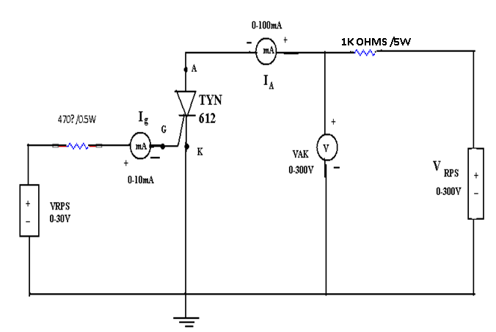
8 | Observation Table, Look-up Table, Output | IG1 (mA)  IG2 (mA) |  |  |  |  |  |  | IA (mA)
  VAK (V) | IA (mA)
  VAK (V) | IA (mA)
9 | Sample Calculations
10 | Graphs, Outputs | 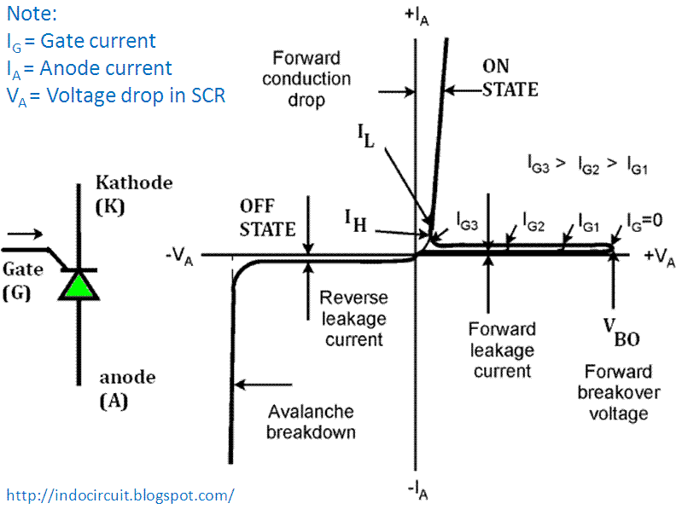
11 | Results & Analysis
12 | Application Areas | - SCR are used in Industrial application such as induction heating, dielectric heating and lamp dimming.  - SCR are used in static AC /DC circuit breakers, control rectifiers, tap changers
13 | Remarks
14 | Faculty Signature with Date

Experiment 02 : Static Characteristics of MOSFET and IGBT

- | Experiment No.: | 2 | Marks |  | Date Planned |  | Date Conducted
1 | Title | Static Characteristics of MOSFET and IGBT
2 | Course Outcomes | Compute static characteristics of MOSFET & IGBT and obtain their performance in terms of voltage & current.
3 | Aim | 1)To obtain the output characteristics.  2)To plot the drain current ID as a function of drain to source voltage VDS with gate to source voltage VGS as parameter.  3) To obtain the transfer characteristics.  4) To plot the drain current ID against gate to source voltage VGS.  5) To find trans conductance from transfer characteristics.
4 | Material / Equipment Required | Lab Manual  MOSFET-IRF540  IGBT-IGRP40u  Voltmeter-0-50V,0-10V,0-100V  Ammeter-0-100A,0-50mA  Dual Power Supply-2  Resistor-100Ohms, 1KOhms, 470ohms
5 | Theory, Formula, Principle, Concept | The MOSFET (Metal Oxide Semiconductor Field Effect Transistor) transistor is a semiconductor device which is widely used for switching and amplifying electronic signals in the electronic devices. The MOSFET is a core of integrated circuit and it can be designed and fabricated in a single chip because of these very small sizes. The MOSFET is a four terminal device with source(S), gate (G), drain (D) and body (B) terminals. The body of the MOSFET is frequently connected to the source terminal so making it a three terminal device like field effect transistor. The MOSFET is very far the most common transistor and can be used in both analog and digital circuits.  The Insulated Gate Bipolar Transistor also called an IGBT for short, is something of a cross between a conventional Bipolar Junction Transistor, (BJT) and a Field Effect Transistor, (MOSFET) making it ideal as a semiconductor switching device. The IGBT Transistor takes the best parts of these two types of common transistors, the high input impedance and high switching speeds of a MOSFET with the low saturation voltage of a bipolar transistor, and combines them together to produce another type of transistor switching device that is capable of handling large collector-emitter currents with virtually zero gate current drive.  The Insulated Gate Bipolar Transistor, (IGBT) combines the insulated gate (hence the first part of its name) technology of the MOSFET with the output performance characteristics of a conventional bipolar transistor, The advantage gained by the insulated gate bipolar transistor device over a BJT or MOSFET is that it offers greater power gain than the standard bipolar type transistor combined with the higher voltage operation and lower input losses of the MOSFET. In effect it is an FET integrated with a bipolar transistor in a form of Darlington type configuration.
6 | Procedure, Program, Activity, Algorithm, Pseudo Code | 1.OUTPUT CHARACTERISTICS  1. Circuit connections are made as shown in the figure.  2. Keep the gate voltage constant say 3.2V, 3.3V, 3.4V.  3. Vary the drain voltage from (0 to 30V) volts in steps of 0.5V and obtain the drain currents.  4. Each time note down the drain current and drain voltage.  5. Repeat the above procedure for different gate voltages.  6. Plot the drain current Vs drain voltage.  7. Calculate the RDS from the graph.  2.TRANSFER CHARACTERISTICS  1. Keep the drain voltage as constant as say 5V,10V and 12V.  2. Vary the gate voltage in steps of 0.1V from 3.0V to 3.8V.  3. Each time obtain the drain current.  4. Repeat the above procedure for different drain voltages.  5. Plot the curve for ID Vs VGS .  6. From the graph find the Trans conductance (GM).
7 | Block, Circuit, Model Diagram, Reaction Equation, Expected Graph | 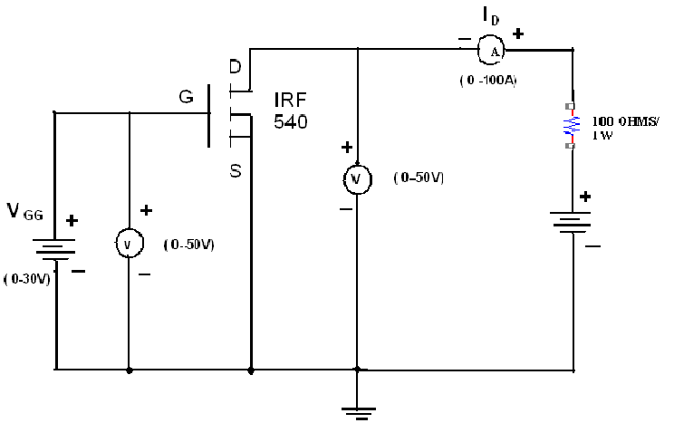  (a)MOSFET Characteristics  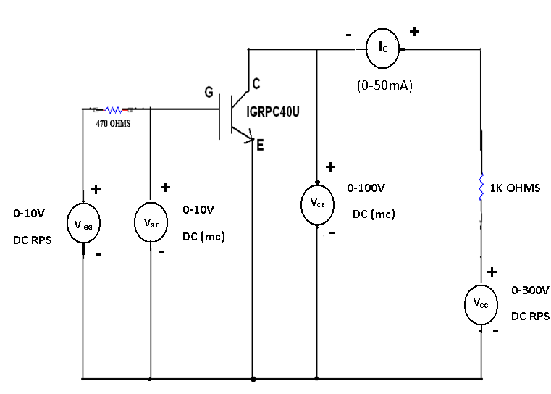  (b) IGBT Characteristics
8 | Observation Table, Look-up Table, Output | Output characteristics  Transfer Characteristics
  VDS In volts | VGS in volts | ID in mA
  5V
  10V
  12V
  VGS In volts | VDS in volts | ID in mA
  3.2V
  3.3V
  3.4V
9 | Sample Calculations
10 | Graphs, Outputs | Drain Characteristics  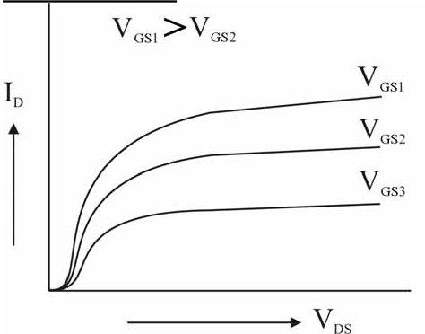  Transfer characteristics  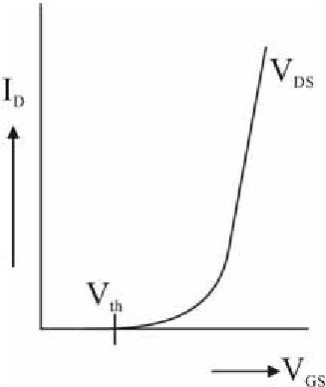
11 | Results & Analysis | The output as well transfer characteristics for MOSFET are obtained and the corresponding graphs as per aim are plotted.
12 | Application Areas | - Transistors are used in low power logic gates, DC motor drives, AC motor drives.  - Transistors are used in isolation circuit such as opto-couplers and pulse transformers.
13 | Remarks
14 | Faculty Signature with Date

Experiment 03 : Characteristics of TRIAC

- | Experiment No.: | 3 | Marks |  | Date Planned |  | Date Conducted
1 | Title | Characteristics of TRIAC
2 | Course Outcomes | Compute static characteristics of TRIAC and obtain their performance in terms of voltage & current.
3 | Aim | To draw V-I characteristics of TRIAC for different values of Gate Currents.
4 | Material / Equipment Required | Lab Manual  TRIAC-BT136  Voltmeter-0-30V  Ammeter-0-30A  Resistors-1Kohms,100ohms  Dual power supply
5 | Theory, Formula, Principle, Concept | A Triac is a high-speed solid-state device that can switch and control AC power in both directions of a sinusoidal waveform. “Triode AC Switch” or Triac for short which is also a member of the thyristor family that be used as a solid state power switching device but more importantly it is a “bidirectional” device. In other words, a Triac can be triggered into conduction by both positive and negative voltages applied to its Anode and with both positive and negative trigger pulses applied to its Gate terminal making it a two-quadrant switching Gate controlled device.  A Triac behaves just like two conventional thyristors connected together in inverse parallel (back-to-back) with respect to each other and because of this arrangement the two thyristors share a common Gate terminal all within a single three-terminal package.Since a triac conducts in both directions of a sinusoidal waveform, the concept of an Anode terminal and a Cathode terminal used to identify the main power terminals of a thyristor are replaced with identifications of: MT1, for Main Terminal 1 and MT2 for Main Terminal 2 with the Gate terminal G referenced the same.
6 | Procedure, Program, Activity, Algorithm, Pseudo Code | 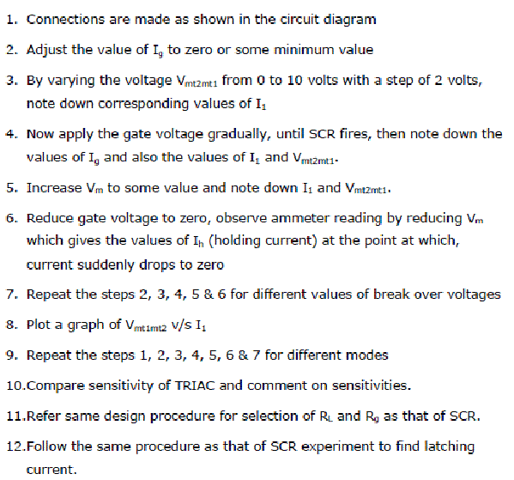
7 | Block, Circuit, Model Diagram, Reaction Equation, Expected Graph | 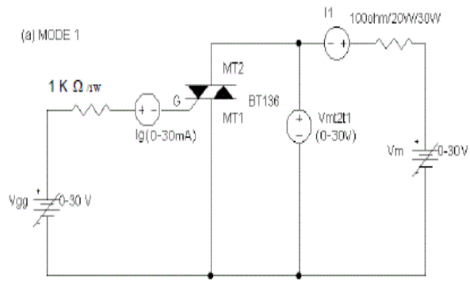  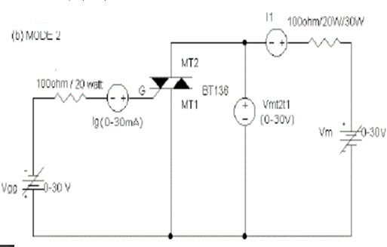  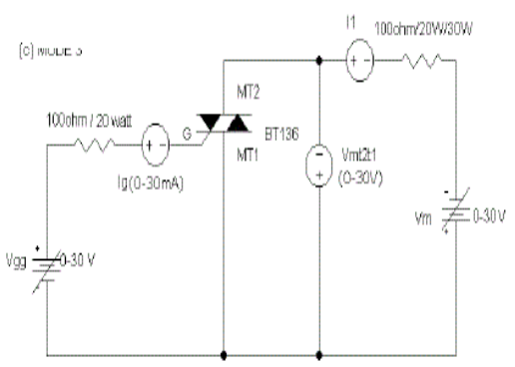  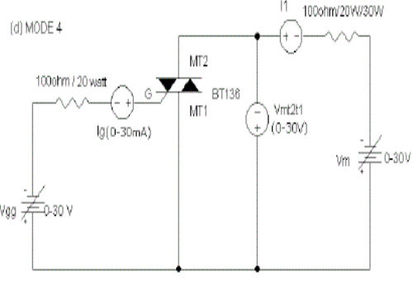
8 | Observation Table, Look-up Table, Output | For Forward Bias  For Reverse Bias
  Sl.No | Voltage(V) | Current(mA)
  Sl.No | Voltage(V) | Current(mA)
9 | Sample Calculations
10 | Graphs, Outputs | 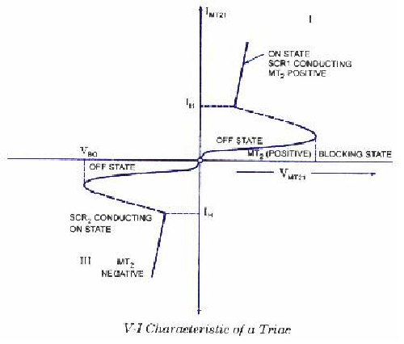
11 | Results & Analysis | The V-I characteristics of TRIAC is plotted on the graph which is true according to theory.
12 | Application Areas | TRIAC’s are used in AC switches, starter circuit for lamps.
13 | Remarks
14 | Faculty Signature with Date

Experiment 04 : SCR turn on circuit using synchronized UJT relaxation Oscillator

- | Experiment No.: | 4 | Marks |  | Date Planned |  | Date Conducted
1 | Title | SCR turn on circuit using synchronized UJT relaxation Oscillator
2 | Course Outcomes | To generate triggering pulses using UJT relaxation oscillator.
3 | Aim | 1.To obtain triggering pulses of sufficient amplitude and width using UTJ.  2. SCR triggering circuit using the pulses obtained in (1).
4 | Material / Equipment Required | Lab Manual  UJT relaxation circuit module  SCR power circuit
5 | Theory, Formula, Principle, Concept | A synchronized UJT triggered circuit using an UJT is shown in the figure. Diode Rectifier converts input ac to dc. Resistor R limits the circuit current to a suitable value for the zener diode and UJT. Zener diode ‘Z’ functions to clip the rectified voltage to a standard level. The zener voltage V 2 is applied to the RC charging circuit. Charging of capacitor C is at a rate determined by R1 and R3.When voltage across the capacitor,V 3 reaches the unijunction threshold voltage ηV 2 , the UJT  junction breaks down and the capacitor C discharges through the primary of pulse transformer. As the current is in the form of pulse, windings of the pulse transformer have pulse voltages at their secondary terminals and can turn on the SCR.As the charging rate of capacitor varies by varying R3, firing angle can be controlled by varying R3.Firing angle can be controlled in a range of 0 0 to 180 0 .
6 | Procedure, Program, Activity, Algorithm, Pseudo Code | - The circuit connections are made as shown for half wave firing circuit for thyristor and observe the wave form across load. Bt varying the potentiometer R observe the waveform on CRO at different points.  - Connect CRO across load terminals.  - Connect voltmeter 0-50V dc across load terminals to get Vdc.  - The potentiometer pf triggering circuit is kept at minimum.  - Check the circuit connections and power on the trainer kit.  - Slowly vary the potentiometer of triggering circuit clockwise to obtain output on CRO and measure the angle.  - Vary the potentiometer of triggering circuit to get different angle. Obtain the reading of α and Idc and Vdc in ammeter and voltmeter and tabulate the readings of α, Idc & Vdc for different firing angles.  - Repeat the above procedure for R and L load connected together, R=100Ω and L=10mH which are provided on the panel.  - Tabulate the readings for R & L load for different α, Idc & Vdc  - Connect free wheeling diode across load terminals and observe the waveforms.  Vdc=Vm(1+cosα) /2π For R load
7 | Block, Circuit, Model Diagram, Reaction Equation, Expected Graph | 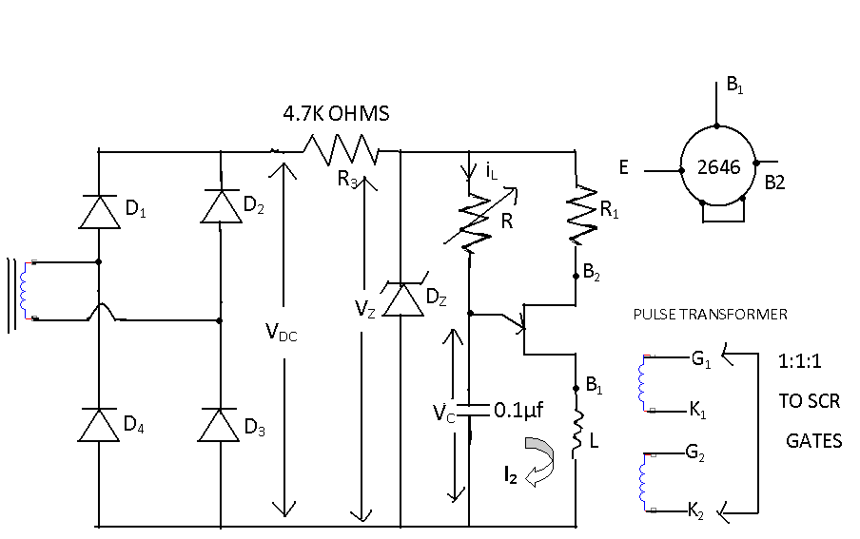  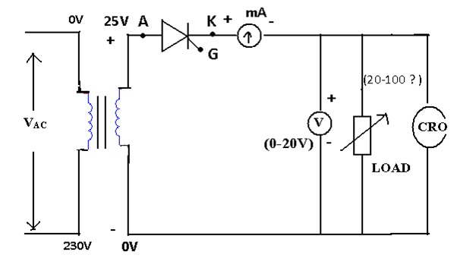
8 | Observation Table, Look-up Table, Output
  α | Π- α | Vdc | Idc | RL | Vdc(th) | Idc(th)
9 | Sample Calculations
10 | Graphs, Outputs | 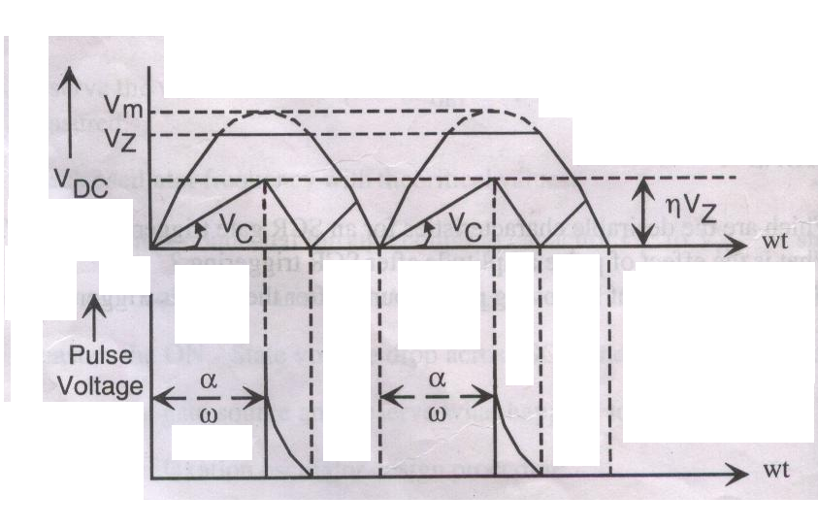  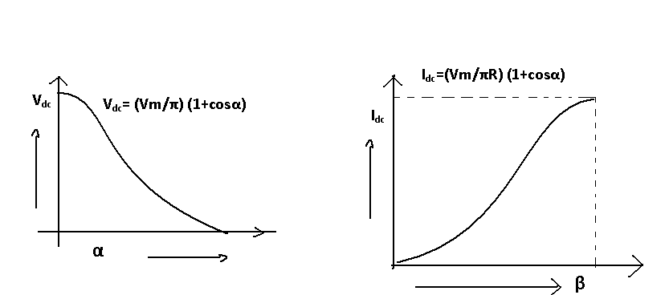
11 | Results & Analysis | Wave forms are observed and verified.
12 | Application Areas | UJT is used as a triggering device for SCR’s, sawtooth generators, phase control and timing circuits
13 | Remarks
14 | Faculty Signature with Date

Experiment 05 : SCR Digital triggering circuit for a single phase controlled rectifier and AC voltage controller
- | Experiment No.: | 5 | Marks |  | Date Planned |  | Date Conducted
1 | Title | SCR Digital triggering circuit for a single phase controlled rectifier and AC voltage controller
2 | Course Outcomes | Generator triggering pulses using SCR digital trigger circuit using single phase controlled rectified AC Voltage controller
3 | Aim | To generate the firing signals for thyristor/TRIAC’S using digital circuits.
4 | Material / Equipment Required | Lab Manual  Digital Firing circuit  Transformer- 240V/12V  SCR-2  Resistor-100ohms  CRO  Voltmeter-0-20V  Ammeter
5 | Theory, Formula, Principle, Concept
6 | Procedure, Program, Activity, Algorithm, Pseudo Code | The circuit connection is made as per the circuit diagram.  1.Connect CRO across Load terminals for channel-1 to see the load wave forms  2. Connect voltmeter 0-50V DC across load terminals A&B to get VDC.  3.Connect triggering circuit outputG1 to G1 of triggering circuit .K 1 to G2to G2,.K 2 to K2 of triggering circuit terminals.  4. Check the circuit connections and power on the trainer kit.  5.Vary the logic switches from 0001 to 1111(15) and vary the firing angle.  6. Tabulate the readings for α, I dc and V d.
7 | Block, Circuit, Model Diagram, Reaction Equation, Expected Graph | 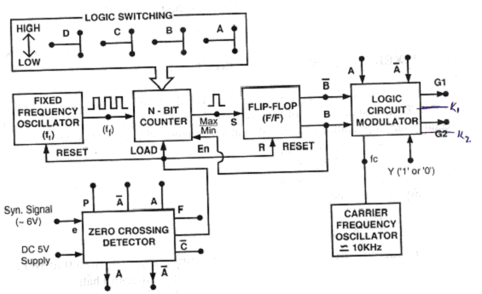  - Block diagram of digital firing circuit  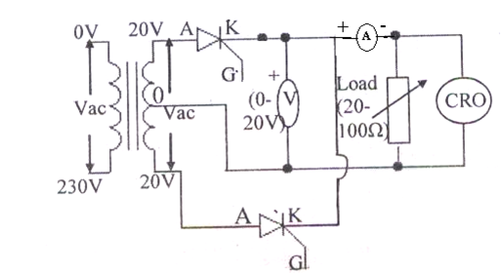
8 | Observation Table, Look-up Table, Output
  α | β =(π- α) | Vdc | Vdc (Th) | Idc (mA)
9 | Sample Calculations
10 | Graphs, Outputs | 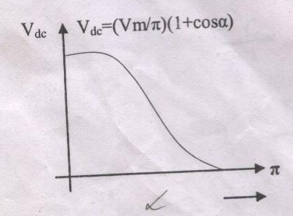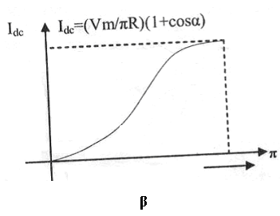
11 | Results & Analysis | Firing signals for thyristors using digital circuits are verified.
12 | Application Areas | AC voltage controllers are used in cyclo converters, matrix converters, Electric welding
13 | Remarks
14 | Faculty Signature with Date

Experiment 06 : Single Phase Controlled full wave rectifier with R and RL loads

- | Experiment No.: | 6 | Marks |  | Date Planned |  | Date Conducted
1 | Title | Single Phase Controlled full wave rectifier with R and RL loads
2 | Course Outcomes | Analyze the performance of a single phase full wave controlled rectified connected to R & RL load
3 | Aim | - To plot VDC Vs firing angle α for R-load.  - To plot VDC Vs conduction angle for R-l load.  - To observe load voltage and SCR wave form on a CRO.  - To observe the effect of FWD (Free wheeling diode) on load voltagewave form.
4 | Material / Equipment Required | Lab Manual  SCR-4 No  Ammeter  Voltmeter  Rheostat  Inductor  Freewheeling Diode  Triggering circuit  CRO
5 | Theory, Formula, Principle, Concepts | In the period 0 < t π/ω; the SCRs T1 and T2 are forward biased and the SCRs T3 and T4 are reverse biased. Then current through the loadand voltage drop across the load are zero. Let the SCRs T1 and T2 be triggered at 24 an angle of α (0<α<π/ω).Then the supply terminals are connected to the load through the SCRs and the current starts flowing through the load via SCRs T1 and T2. Therefore the supply voltage appears across the load with a drop of R and the voltage drop across the SCRs is zero when they are conducting (SCR is assumed ideal).In the period (π/ω<t<2π/ω); the SCRs T1 and T2 are Reversed biased hence cannot conduct and T3 and T4 are forward biased. When they are triggered at an angle of (π+α)/ ω[0< (π+α)/ ω <2π/ ω]. Then the supply terminals are connected to the load through the SCRs and the current starts flowing through the load via SCRs T3 and T4. Therefore the supply voltage appears across the load with a drop R and the voltage drop across the SCRs is zero when they are conducting (SCR is assumed ideal).These SCRs continue to conduct up to 2π/ ω. Again during the third positive Half cycle supply is positive and SCRs T1 and T2 are forward biased, if we give triggering SCRs start conducting and this cycle repeats
6 | Procedure, Program, Activity, Algorithm, Pseudo Code | The circuit connection is made as per the circuit diagram.  1.Connect CRO across Load terminals A and B for channel-1 to see the load wave forms  2. Connect voltmeter0-50V DC across load terminals A&B to get VDC.  3.Connect triggering circuit outputG1 to G1 of triggering circuit .K 1 to G2to G2,.K 2 to K2, G3to G3, K 3 to K3, G4 to G4 and K4 to K4 of triggering circuit terminals.  4.The potentiometer of triggering circuit is kept at minimum.  5. Check the circuit connections and power on the trainer kit.  6. Slowly vary the potentiometer of triggering circuit clockwise , to obtain output on CRO  7. To measure the angle the input 0 to 25V AC from triggering circuit transformer output (C&D) to CRO channel II.  8. Align the two output waveforms on CRO.  9. Vary the potentiometer of triggering circuit to get different angle and obtain the readings of α (angle) and I dc and V dc in Ammeter and voltmeter and tabulate the readings of α, I dc and V dc and π- α for different firing angles.  10.Repeat the above procedure for R and L load connected together, R=100Ω and L=10mH which are provided on the panel.  11.Tabulate the readings for R and L loads for different α, I dc and V dc.  12. Connect free wheeling diode across load terminals and observe the waveforms. Vdc = Vm Π (1+COS α) for R load and R-L load with FWD. Vdc = 2 Vm (COS α) / Π for R-L load.  13. Verify the values of Vdc and Idc theoretically.
7 | Block, Circuit, Model Diagram, Reaction Equation, Expected Graph | 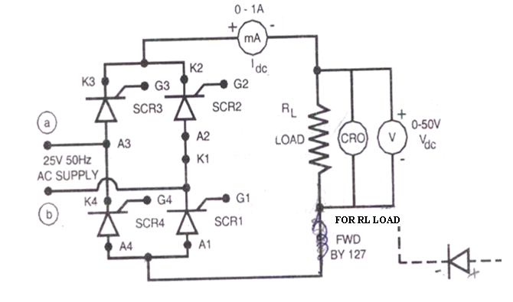  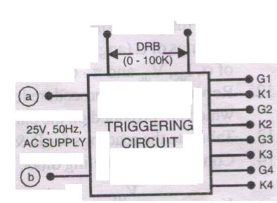
8 | Observation Table, Look-up Table, Output | - For R-Load  (B) For R-L Load
  α
  VL in V
  Idc in mA
  Π-α
  VL (Th)
  α
  VL in V
  Idc in mA
  Π-α
  VL (Th)
9 | Sample Calculations
10 | Graphs, Outputs | - For R- Load  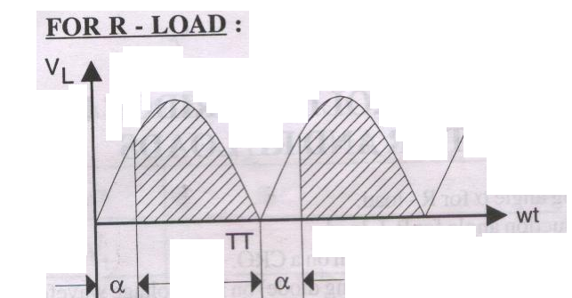  - For R-L Load  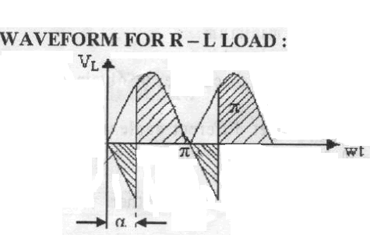  Expected Graph  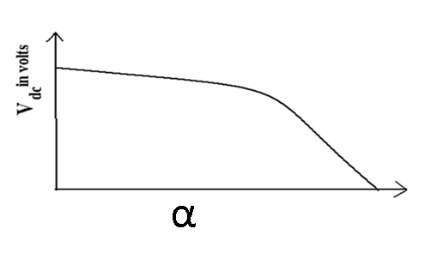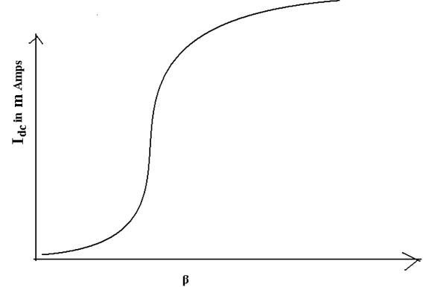
11 | Results& Analysis | Firing angles and conduction angles are obtained from R and R-L load and graphs are plotted.
12 | Application Areas | Control rectifiers are used in speed control of DC motor, Universal motors, lamp dimming
13 | Remarks
14 | Faculty Signature with Date

Experiment 07 : AC voltage Controller using TRIAC and DIAC combination

- | Experiment No.: | 7 | Marks |  | Date Planned |  | Date Conducted
1 | Title | AC voltage Controller using TRIAC and DIAC combination
2 | Course Outcomes | Analyze the performance of AC voltage controller applied to R & RL load using TRIAC and DIAC.
3 | Aim | - To observe variation of intensity of light  - To plot load current Vs delay angle α.  - To plot load voltage Vs conduction angle (π-α).
4 | Material / Equipment Required | Lab Manual  Lamp  Voltmeter-0-20V  Ammeter-0-500mA  TRIAC-BT136  DIAC-BR100  DRB 0-10K
5 | Theory, Formula, Principle, Concept
6 | Procedure, Program, Activity, Algorithm, Pseudo Code | - Connections are made as show in the circuit diagram.  - DRB resistance is varied in steps. At each step values of load current & voltage are noted down corresponding delay angle and conduction angle are measured on CRO.  - The variation of intensity of light is observed for variations in R.  - Plot the graph of I_{L} (rms) Vs delay angle α and VL (rms) Vs conduction angle are drawn.
7 | Block, Circuit, Model Diagram, Reaction Equation, Expected Graph | 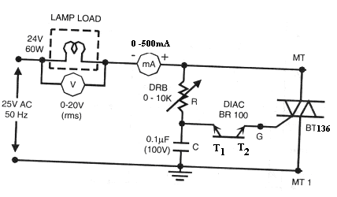
8 | Observation Table, Look-up Table, Output
  α | V_{L} | π-α | I_{L} | V_{L} (TH)
9 | Sample Calculations
10 | Graphs, Outputs | 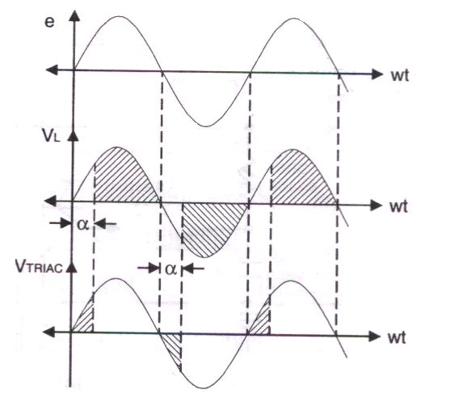  Expected Waveform  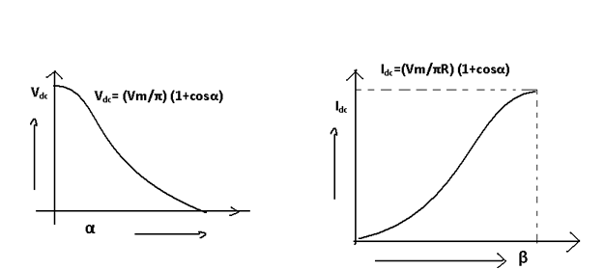
11 | Results & Analysis | The above experiment is performed successfully and corresponding graphs are obtained. Intensity of the light is obtained.
12 | Application Areas | AC voltage controllers are used in power generation, power transmission, electric heating, induction heating.
13 | Remarks
14 | Faculty Signature with Date

Experiment 08 : Speed Control of DC Motor using single semi Converter

- | Experiment No.: | 8 | Marks |  | Date Planned |  | Date Conducted
1 | Title | Speed Control of DC Motor using single semi Converter
2 | Course Outcomes | Control the speed of DC motor using semi converter by varying firing angle.
3 | Aim | - To observe the variations of speed of dc motor  - To plot load current Vs delay angle α  - To plot load voltage Vs conduction angle β  - To observe the effect of free wheeling diode on load voltage waveform
4 | Material / Equipment Required | Lab Manual  DC Motor  Ammeter  Voltmeter  Semi converter
5 | Theory, Formula, Principle, Concept | In the period 0 < t π/ω; the SCRs T1 and Diode D1 are forward biased and the SCR T2 and Diode D2 are reverse biased. Then current through the load and voltage drop across the load are zero. Let the SCR T1 be triggered at an angle of α (0<α<π/ω).As the Diode D1 is already conducting the supply terminals are connected to the load through the SCR and Diode, the current starts flowing through the load via SCR T1 and Diode D1. Therefore the supply voltage appears across the load, the voltage drop across the SCR and the Diode is zero when they are conducting (SCR, Diode are assumed ideal). Soon after π/ω load voltage tends to reverse, Free wheeling Diode gets forward biased and starts conducting. The load, or output current is transferred from T1, D1 to FWD. As SCR T1 is reverse biased at t = π/ω + current flows through FWD and T1 is turned off. The load terminals are short circuited through FWD therefore load voltage is zero during [π/ω<t< (π+α) /ω]. During the period (π/ω<t<2π/ω); T2 and Diode D2 are forward biased. When T2 is triggered at an angle of (π+α) /ω, [0<33(π+α)/ω <2π/ω], then the FWD is reverse biased and is turned off. During this period supply terminals are connected to the load through the SCR and the Diode D2, the load current shifts from FWD to T2 and D2. Therefore the supply voltage appears across the load. The voltage drop across the SCR and Diode is zero when they are conducting (SCR, Diode are assumed ideal). SCR T2 and Diode D2 continue to conduct up to 2π/ ω. For the next half cycle the load current is transferred from T2 and D2 to the FWD and SCR T1 and Diode D1 are forward biased, if we give triggering SCR starts conducting and this cycle repeats.
6 | Procedure, Program, Activity, Algorithm, Pseudo Code | - Connections are made as shown.  - DRB resistance is varied in steps and at each step rms values of load current & load volt are noted.  - At each setting of DRB. The speed in rpm is also measured using a tachometer.  - The speed variation is observed for variation in DRB resistance.  - graphs of speed Vs Irms & N Vs Vrms are plotted
7 | Block, Circuit, Model Diagram, Reaction Equation, Expected Graph | 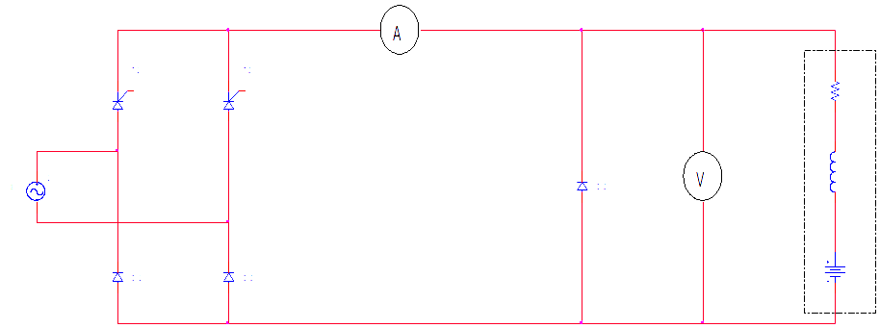
8 | Observation Table, Look-up Table, Output
  Speed in RPM | V_{RMS} (V) | I_{RMS} (A)
9 | Sample Calculations
10 | Graphs, Outputs | EXPECTED WAVEFORMS:  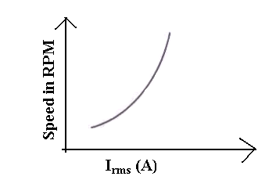
11 | Results& Analysis | The variation of speed of AC motor is observed and corresponding graphs are plotted
12 | Application Areas | Control rectifiers are used in speed control of DC motor, Universal motors, lamp dimming.
13 | Remarks
14 | Faculty Signature with Date

Experiment 09 : Speed Control of Stepper Motor

- | Experiment No.: | 9 | Marks |  | Date Planned |  | Date Conducted
1 | Title | Speed Control of Stepper Motor
2 | Course Outcomes | Control the speed of stepper motor.
3 | Aim | To observe variation of speed control of DC Stepper motor
4 | Material / Equipment Required | - Permanent magnet, Bifilar wound, two phase  - steps per revolution: 200  - step angle:1.8⁰ 0.1⁰ non-cumulative  - No of loads :6  - 1 kg cm =0.1 Nm=13.9 Z-in
5 | Theory, Formula, Principle, Concept | Every motor converts power. Electric motors convert electricity into motion. Stepper motors convert electricity into rotation. Not only does a stepper motor convert electrical power into rotation, but it can be very accurately controlled in terms of how far it will rotate and how fast.  Stepper motors are so named because each pulse of electricity turns the motor one step. Stepper motors are controlled by a driver, which sends the pulses into the motor causing it to turn. The number of pulses the motor turns is equal to the number of pulses fed into the driver. The motor will spin at a rate that is equal to the frequency of those same pulses.  Stepper motors are very easy to control. Most drivers are looking for 5 volt pulses which just so happen to be the voltage level of most integrated circuits. You merely need to design a circuit to output pulses or use one of ORIENTAL MOTOR's pulse generators.  One of the most remarkable features of stepper motors is their ability to position very accurately. This will be covered in depth later on. Stepper motors are not perfect, there are always some little inaccuracies. ORIENTAL MOTOR's standard stepper motors have an accuracy of ± 3 arc minutes (0.05°). The remarkable feature of steps motors, though, is that this error does not accumulate from step to step. When a standard stepper motor travels one step it will go 1.8° ± 0.05°. If the same motor travels one million steps, it will travel 1,800,000° ± 0.05°. The error does not accumulate.  Stepper motors can respond and accelerate quickly. They have low rotor inertia that can get up to speed quickly. For this reason stepper motors are ideal for short, quick moves.
6 | Procedure, Program, Activity, Algorithm, Pseudo Code | - The circuit connections are made as shown  - connect +ve supply connected RS to green terminals  - connect – blue pin to blue terminal  Red pin to red terminal control winding  Yellow pin to yellow terminal of stepper motor  Black pin to black terminal  - Connect the terminals of firing circuit from logic controller to MOSFET gate terminal as shown below.  A. For clockwise direction G1 to G1  G2 to G2  G3 to G3  G4 to G4  B. For anticlockwise direction G1 to G4  G2 to G3  G3 to G2  G4 to G1  - Stepper motor rotates at 1.8⁰ ± 0.1⁰ for each step non cumulative.  - The frequency of logic switches is measured at any one gate o/p terminal.  - The actual frequency is given by 4 * measured frequency  - The RPM measured are noted down N-m  - The speed can also be calculated as follow N-actual.
7 | Block, Circuit, Model Diagram, Reaction Equation, Expected Graph | 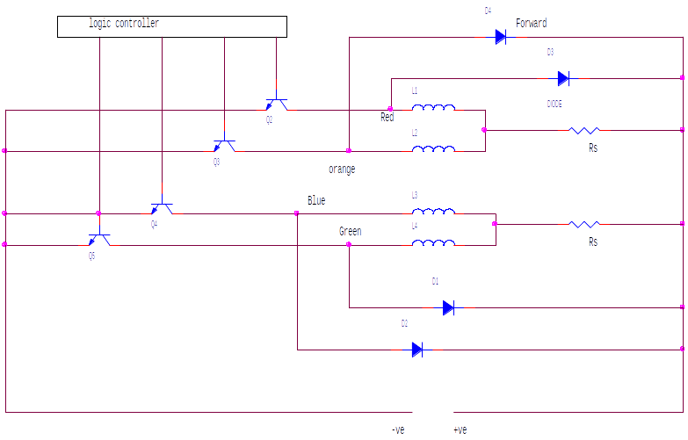  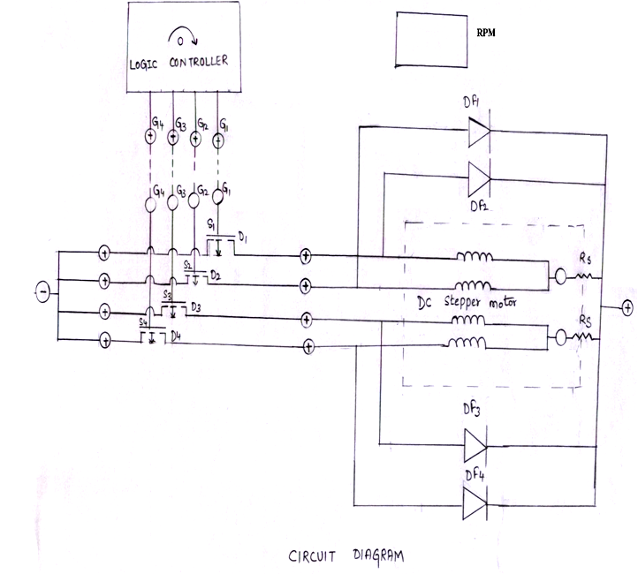
8 | Observation Table, Look-up Table, Output
  Frequency | Speed in RPM | N actual  (Theoretical) RPM | Time in sec
9 | Sample Calculations | F=Frequency  Step per revolution=200  RPM Actual= (4*F*60) / 200 in rotation / min.
10 | Graphs, Outputs | EXPECTED WAVEFORMS:  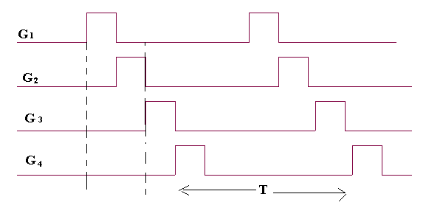  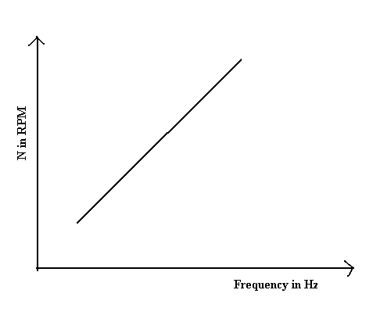
11 | Results & Analysis | The variation of speed control of DC stepper motor so observed.
12 | Application Areas | Stepper motors are used for precise positioning with a motor such as hard disc drives, robotics, antennas, telescopes etc
13 | Remarks
14 | Faculty Signature with Date

Experiment 10 : Speed Control of universal motor using AC voltage regulator

- | Experiment No.: | 10 | Marks |  | Date Planned |  | Date Conducted
1 | Title | Speed Control of universal motor using AC voltage regulator
2 | Course Outcomes | Control the speed of universal motor using controlled rectifier or AC voltage controller
3 | Aim | - To observe the variations of speed of AC Motor  - To plot speed Vs RMS current and speed Vs rms volt.
4 | Material / Equipment Required | Lab Manual
5 | Theory, Formula, Principle, Concept
6 | Procedure, Program, Activity, Algorithm, Pseudo Code | - Connections are made as shown.  - DRB resistance is varied in steps and at each step rms values of load current & load volt are noted.  - At each setting of DRB. The speed in rpm is also measured using a tachometer.  - The speed variation is observed for variation in DRB resistance.  - graphs of speed Vs Irms & N Vs Vrms are plotted
7 | Block, Circuit, Model Diagram, Reaction Equation, Expected Graph | 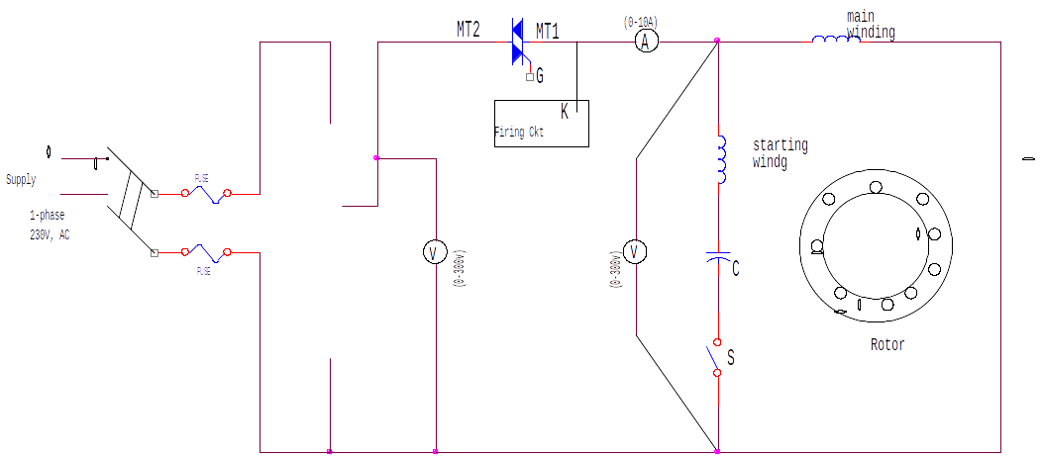
8 | Observation Table, Look-up Table, Output
9 | Sample Calculations
10 | Graphs, Outputs | Expected waveforms:  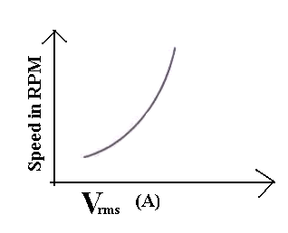
11 | Results & Analysis | The variation of speed of AC motor is observed and corresponding graphs are plotted
12 | Application Areas | Universal motors are used in portable power tools and equipments, house hold applications.
13 | Remarks
14 | Faculty Signature with Date

Experiment 11 : Speed control of separately excited DC motor using an IGBT or MOSFET chopper

- | Experiment No.: | 11 | Marks |  | Date Planned |  | Date Conducted
1 | Title | Speed control of separately excited DC motor using an IGBT or MOSFET chopper
2 | Course Outcomes | Control the speed of a separately exited DC motor using MOSFET chopper by varying duty cycle of the thyristor.
3 | Aim | To construct a chopper circuit and study its time ratio (TRC) controls.
4 | Material / Equipment Required | Lab Manual  MOSFET chopper Module  DC Motor
5 | Theory, Formula, Principle, Concept | (δ)= (T_{ON /}T)
6 | Procedure, Program, Activity, Algorithm, Pseudo Code | 1. Circuit connections are made as shown in the circuit in the diagram by connecting field of the motor to field supply of the chopper power unit and armature of the motor to load points in the chopper.  2. The gate and source terminal of the power switch /MOSFET is connected to the respective firing signal.  3. Keep input DC voltage at 100 to 200v  4. Check all the connections and confirm whether the connections made are correct before switching on the equipment.  5. Switch on the chopper unit and also DC power supply to the chopper.  6. Keeping frequency constant vary duty cycle of corresponding load voltage for each step.  7. The output waveforms are seen on the CRO.  8. Tabulated load speed of the motor for different duty cycles.
7 | Block, Circuit, Model Diagram, Reaction Equation, Expected Graph | 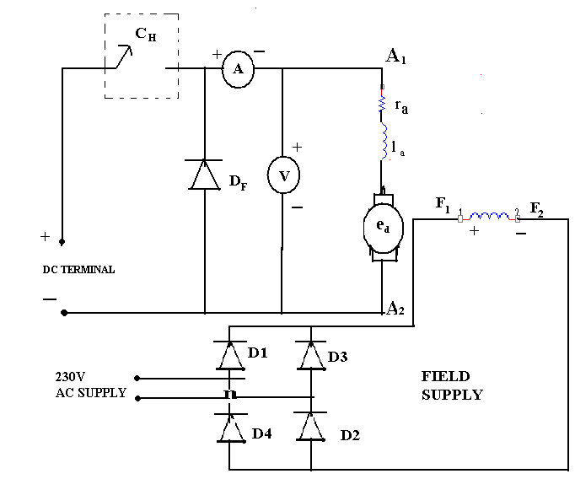
8 | Observation Table, Look-up Table, Output
  LOAD VOLTAGE | CURRENT (A) | SPEED IN RPM | DUTY CYCLE IN % δ
9 | Sample Calculations
10 | Graphs, Outputs
11 | Results & Analysis | DC chopper is constructed and its performance is studied.
12 | Application Areas | Choppers are used in railway traction, battery charges, switched capacitance filters, variable frequency drives, class D electronic amplifiers, battery operated electric cars.
13 | Remarks
14 | Faculty Signature with Date

Experiment 12 : Design of Snubber circuit

- | Experiment No.: | 12 | Marks |  | Date Planned |  | Date Conducted
1 | Title | Design of Snubber circuit
2 | Course Outcomes | Design the snubber circuit for the protection of power circuit from faults
3 | Aim | Design of Snubber Circuit.
4 | Material / Equipment Required | Lab Manual  SCR  Resistor  Capacitor
5 | Theory, Formula, Principle, Concept | dv/dt=0.632V_{S}/R_{S} C_{S}  Where R_{S} C_{S} is the Snubber time constant.  R_{S}=V_{S}/I_{TD}  Where I_{TD} is the discharging current of the capacitor.  Due to overheating, over voltage, over current or excessive change in voltage or current switching devices and circuit components may fail. From over current they can be protected by placing fuses at suitable locations. Heat sinks and fans can be used to take the excess heat away from switching devices and other components. Snubber circuits are needed to limit the rate of change in voltage or current (di/dt or dv/dt) and over voltage during turn-on and turn-off. These are placed across the semiconductor devices for protection as well as to improve the performance. Static dv/dt is a measure of the ability of a thyristor to retain a blocking state under the influence of a voltage transient. These are also used across the relays and switches to prevent arcing.  These are placed across the various switching devices like transistors, thyristors, etc. Switching from ON to OFF state results the impedance of the device suddenly changes to the high value. But this allows a small current to flow through the switch. This induces a large voltage across the device. If this current reduced at faster rate more is the induced voltage across the device and also if the switch is not capable of withstanding this voltage the switch becomes burn out. So auxiliary path is needed to prevent this high induced voltage  Similarly when the transition is from OFF to ON state, due to uneven distribution of the current through the area of the switch overheating will takes place and eventually it will be burned. Here also snubber is necessary to reduce the current at starting by making an alternate pat
6 | Procedure, Program, Activity, Algorithm, Pseudo Code | - Switch S is turned on at t=0, a step voltage is applied across SCR. This voltage will have a high dv/dt. The value of snubber circuit components is calculated by using formula.  - When SCR is in forward blocking state the capacitor will charge.  - Therefore voltage across SCR will increase gradually. Thus the rate of change of voltage across SCR is reduced.  - When SCR is turned on the charged capacitor will discharge through resistance R and SCR. Thus R limits the discharge current of the capacitor and prevents damage of SCR due to over current.
7 | Block, Circuit, Model Diagram, Reaction Equation, Expected Graph | 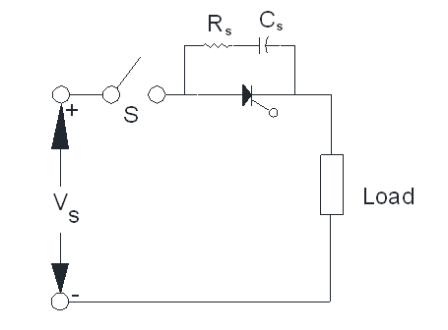
8 | Observation Table, Look-up Table, Output | For dv/dt= ---------
  t= | VA
9 | Sample Calculations
10 | Graphs, Outputs
11 | Results & Analysis | For given dv/dt ratings, design a snubber circuit by using the formula and observe the response of the circuit Shown by the graph
12 | Application Areas | Snubber circuits are used across the relays and switches to prevent arcing.
13 | Remarks
14 | Faculty Signature with Date

